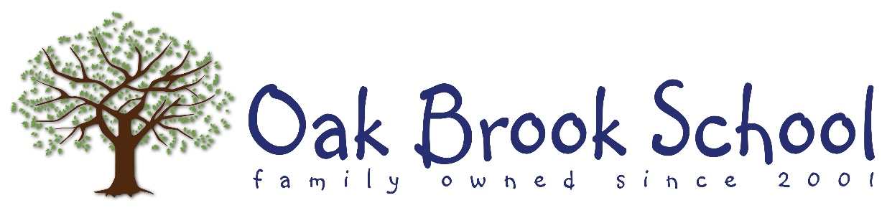

*Dear OBS Families,*

Our class is beginning the theme, “My Family.” During the next few weeks, we will be exploring the different members of families, family roles, and unique qualities of families. This theme is all about you, so here are some ways you can support what your child will be learning at home. • Look at family photos with your child and talk about family members and their special qualities. • Share special family traditions and how they began. • Enjoy a family activity with your child, such as cooking, reading together, or playing a game. • Talk about family roles and responsibilities and choose one or two ways in which your child can help other family members. Throughout the My Family theme, I will be teaching children about kindness and what they can do to express kindness to others. You can help by identifying examples of kind acts at home and when you go places. Enjoy talking and spending family time with your child!

CURRICULUM CHRONICLE – Pre-K

NOVEMBER

OAK BROOK SCHOOL

550 Trinity Drive Allen TX 75002 ⦁ (P) 214-383-5093 ⦁ (F) 214-383-5162 www.oakbrookschoolallen.com

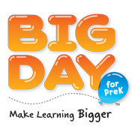

***People We Meet - Week 2***

**BIG Idea:** The workers in my community help everyone.

**Concepts:** Community workers, jobs and careers, helping others

**Theme Vocabulary:** doctor, firefighter, librarian, mail carrier, police officer, work, workers

***Places We Go - Week 1***

**BIG Idea:** I visit many places in my community.

**Concepts:** Places in the community, things to do in the community, going to the library, community responsibility

**Theme Vocabulary:** apartments, block, building, community, firehouse, hospital, library, neighborhood, park, sidewalk

***Things That Move-Week 3***

**BIG Idea:** Transportation is for doing jobs and getting around my community.

**Concepts:** Transportation, machines, how things move, safety rules

**Theme Vocabulary:** vehicle, transportation, safety, travel, traffic, passenger, driver

**Going Green! – *Week 4***

**BIG Idea:** I can make a difference.

**Concepts:** Caring for our Earth, conserving resources, recycling, using recyclable materials

**Theme Vocabulary:** recycle, Earth, protect, reduce, trash, environment, reuse

OAK BROOK SCHOOL

550 Trinity Drive Allen TX 75002 ⦁ (P) 214-383-5093 ⦁ (F) 214-383-5162 www.oakbrookschoolallen.com