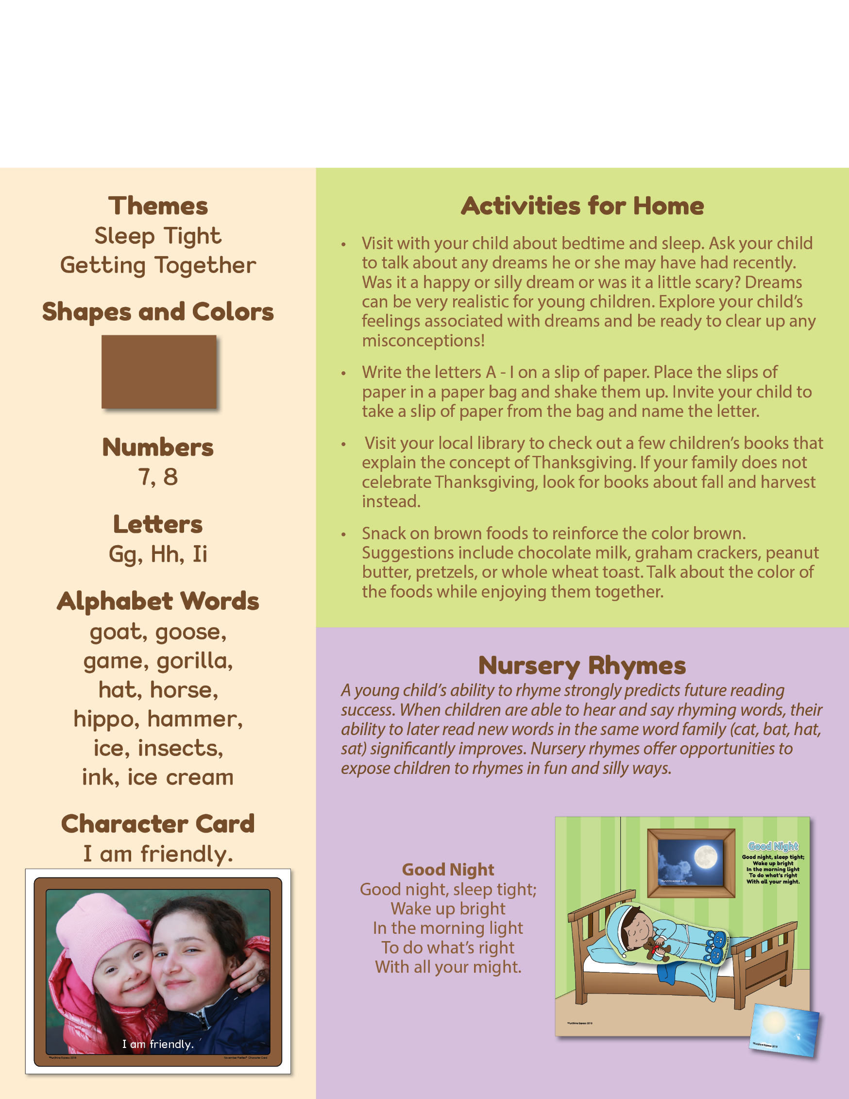­­

November

Curriculum Chronicle

Early Learners 1&2, Preschool 1&2

`

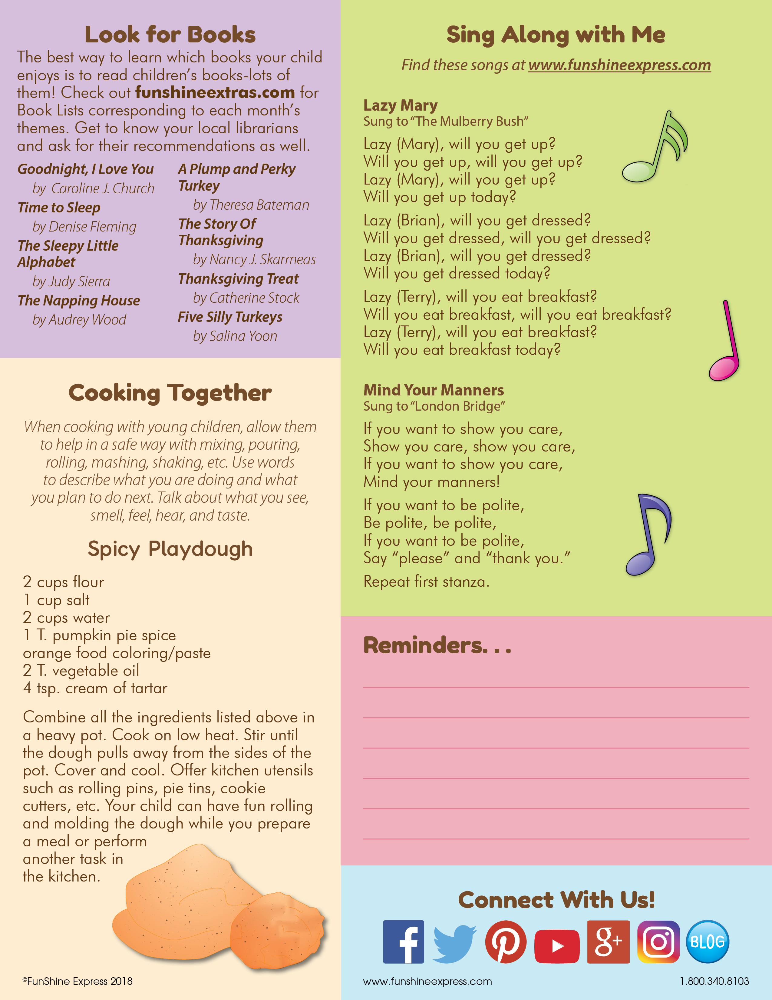­

|  |  |  |  |  |  |  |
| --- | --- | --- | --- | --- | --- | --- |
| NOVEMBER 2018 | | | | | | |
| S | M | T | W | Th | F | S |
|  |  |  |  | 1 | 2 | 3 |
| 4 | 5 | 6 | 7 | 8 | 9 | 10 |
| 11 | 12 | 13 | 14 | 15 | 16 | 17 |
| 18 | 19 | 20 | 21 | 22 | 23 | 24 |
| 25 | 26 | 27 | 28 | 29 | 30 |  |
|  |  |  |  |  |  |  |

1 – TOYS FOR TOTS KICK-OFF

3 – FALL FESTIVAL

14 – BB DELIVERY DAY

16 – THANKSGIVING FEAST

21 – EARLY RELEASE *(*closing at 12*)

22-23 – THANKSGIVING BREAK

28 – PICS WITH SANTA

30 – PNO

**Add Notes Here**